PIZZA SALES SQL QUERIES
KPI’s
1. Total Revenue:
select round(sum(total_price),2) as 'Total Revenue' from pizza_sales;
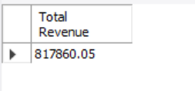
2. Average Order Value
SELECT SUM(total_price) / COUNT(DISTINCT order_id) AS Avg_order_Value FROM pizza_sales;
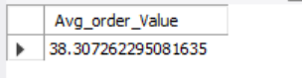

3. Total Pizzas Sold
select SUM(quantity) AS 'Total_pizza_sold' FROM pizza_sales;


4. Total Orders
SELECT COUNT(DISTINCT order_id) AS Total_Orders FROM pizza_sales;


5. Average Pizzas Per Order
select round(sum(quantity)/count(distinct(order_id)),2) 'Avg Pizza per Order'
from pizza_sales;


B. Daily Trend for Total Orders
select dayname(STR_TO_DATE(order_date, '%d-%m-%y'))'Week day ', count(distinct(order_id)) 'Total_Order'
from pizza_sales
group by dayname(STR_TO_DATE(order_date, '%d-%m-%y'));
Output:

C. Monthly Trend for Orders
select monthname(STR_TO_DATE(order_date,'%d-%m-%y')) 'Month', count(distinct(order_id)) 'Order Count'
from pizza_sales
group by monthname(STR_TO_DATE(order_date, '%d-%m-%y'));


D. % of Sales by Pizza Category
select pizza_category, round(sum(total_price),2) as 'Total Revenue',
round(sum(total_price) * 100/(select sum(total_price) from pizza_sales),2) 'Percentage'
from pizza_sales
group by pizza_category;
Output
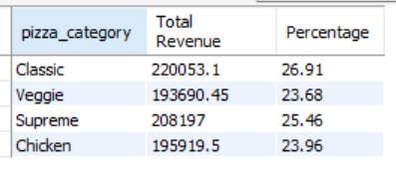
E. % of Sales by Pizza Size
select pizza_size, round(sum(total_price),2) 'Total Revenue',
round(sum(total_price) * 100/ (select sum(total_price) from pizza_sales),2) 'Percentage'
from pizza_sales
group by pizza_size;
Output
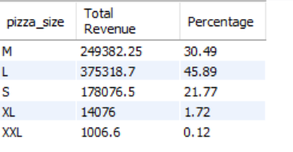

F. Total Pizzas Sold by Pizza Category
select pizza_category, count(quantity) as 'Pizza_Sold' from pizza_sales
group by pizza_category;
Output
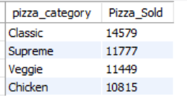
G. Top 5 Pizzas by Revenue
select pizza_name, sum(total_price) 'Total_Revenue' from pizza_sales
group by pizza_name
order by Total_Revenue desc
limit 5;


H. Bottom 5 Pizzas by Revenue
select pizza_name, sum(total_price) 'Total_Revenue' from pizza_sales
group by pizza_name
order by Total_Revenue
limit 5;
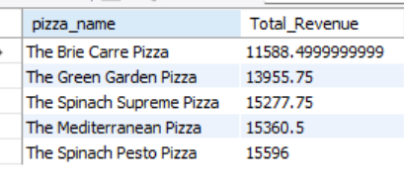

I. Top 5 Pizzas by Quantity
select pizza_name, sum(quantity) 'Total_Pizza_Sold' from pizza_sales
group by pizza_name
order by Total_Pizza_Sold desc
limit 5;
Output

J. Bottom 5 Pizzas by Quantity
select pizza_name, sum(quantity) 'Total_Pizza_Sold' from pizza_sales
group by pizza_name
order by Total_Pizza_Sold
limit 5;
Output

K. Top 5 Pizzas by Total Orders
select pizza_name, count(distinct(order_id)) 'Total_Pizza_orders' from pizza_sales
group by pizza_name
order by Total_Pizza_orders desc
limit 5;

L. Bottom 5 Pizzas by Total Orders
select pizza_name, count(distinct(order_id)) 'Total_Pizza_orders' from pizza_sales
group by pizza_name
order by Total_Pizza_orders desc
limit 5;


